**FPST 3373 CFAST_FDS Date: Name:**

1. Using CFAST, design a mechanical smoke exhaust system. The figure below only indicates five ceiling vents on the ceiling.

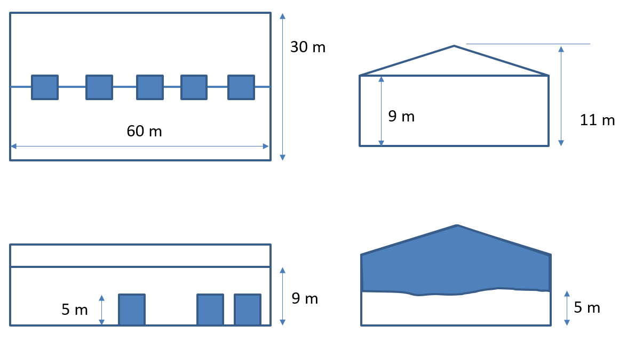

* 1. Simulation time 3600s
  2. Floor dimension (30 m by 60 m)
  3. Pitched roof (11 m at the center, 9 m at both ends)
  4. Three open 5 m by 5 m (H) roller shutter doors initially open
  5. Fire size: constant 15 MW
  6. Plot the layer heights for the following 4 cases in one figure and check if there is any difference. Based on your physical intuition, should these four be different?
     1. Case 0:
        1. The number of ceiling vents (square): 5
        2. Vent area: 10 m2
        3. Exhaust rate for each : 12 m3/s
     2. Case 1:
        1. The number of ceiling vents (square): 5
        2. Vent area: 5 m2
        3. Exhaust rate for each : 12 m3/s
     3. Case 2:
        1. The number of ceiling vents (square): 1
        2. Vent area: 5 m2
        3. Exhaust rate for each : 60 m3/s
     4. Case 3:
        1. The number of ceiling vents (square): 1
        2. Vent area: 1 m2
        3. Exhaust rate for each : 60 m3/s

1. Submit one excel file that includes the layer height data of the four cases above and one figure of comparison.